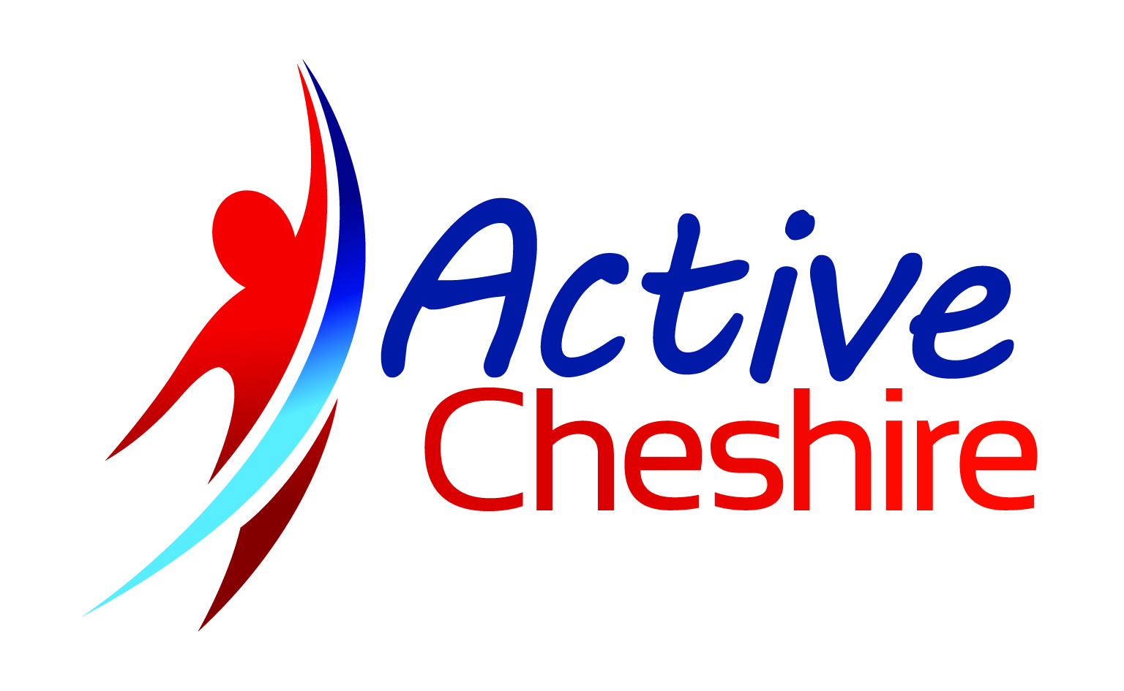
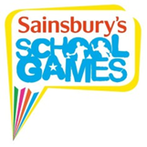
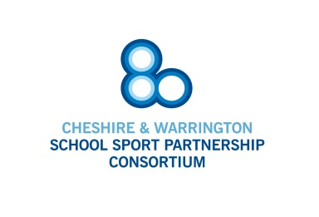

Cheshire & Warrington School Games Festival

Sportshall Athletics (Year 5&6)

KEY INFORMATION
Age Category | Year 5&6
Squad size | Minimum of 9 boys and 9 girls.  Maximum of 15 boys and 15 girls.
Gender | Mixed.
Eligibility | - Each child may take part in a maximum of two track and two field events.
Basic Rules | - Events:  Obstacle Relay – requiring four girls and four boys per team  1+1 Lap Relay – requiring two girls and two boys per team  2+2 Lap Relay – requiring two girls and two boys per team  6 Lap Paarlauf – requiring two girls and two boys per team  Over / Under Relay - requiring four girls and four boys per team  4 x 1 Lap Relay - requiring four girls and four boys per team  Soft Javelin – requiring three girls and three boys per team  Chest Push – requiring three girls and three boys per team  Vertical Jump – requiring three girls and three boys per team  Standing Long Jump – requiring three girls and three boys per team  Standing Triple Jump – requiring three girls and three boys per team  Speed Bounce. – requiring three girls and three boys per team  - Children must wear suitable footwear.

COMPETITION DELIVERY DETAILS
Name | Adam Burgess
Role | Event Deliverer
Organisation | Sportshall Associates

